Background
This document contains programs to help to get a hands on for the subject Python Programming.

In windows, download python, if NOT already installed, from the following site, and double click to install, provide the administrative rights be available.

Setting up environment variable PATH
Above version 2.4, the PATH for python is usually set by default during installation. This can be verified by typing the following command at command prompt window, which is obtained by typing cmd, at Run window.
C:>python
If Python path is set then python application will start and the Primary Prompt “>>>” will appear as shown. If not set, then an error
“'python' is not recognized as an internal or external command,
operable program or batch file.” Will be displayed at the Command prompt window

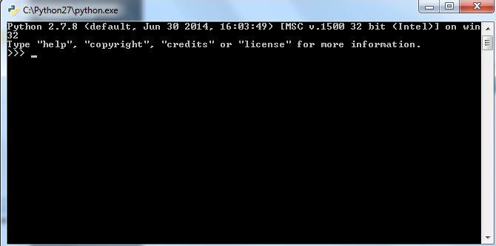

For setting PATH go to Control Panel ->Advanced System settings and select “Advanced” Tab and then click on “Environment Variable” button, at the bottom of the table, to get the Environment Variables window, as shown below. In System variables, click the “Edit” button and then type Python path as “;C:\Python27” or whatever, directory name, python has been installed on the system.

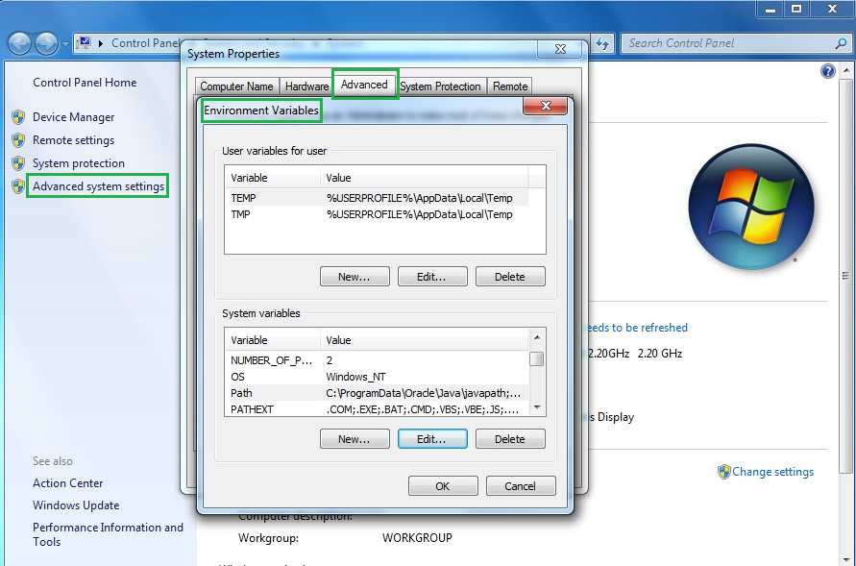

Setting Class Path:
For certain modules, the Python CLASSPATH can be set using system variable PYTHONPATH and assigning path of the module required.

Starting Python from Menu:
If Python application is to be started from the Menu, then select Python (Command line) to obtain python command prompt window directly as show below

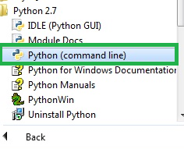

3 ways to execute python program
- Either run each command separately at python prompt
>>> - Primary prompt
… - Secondary prompt when enter is pressed
- Run set of commands at Python prompt as a .py file >>>execfile(“test.py”,list) i.e list = [a,b,c] parameter list
- Run at command prompt c:>python test.py a b c
(Provided %path% is set to python directory)
Use python (command line)

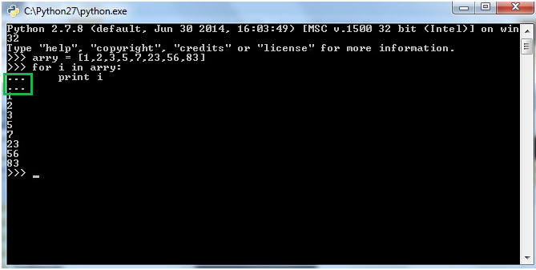

Python installation on Unix

Extract the tarball
tar xvfz Python-3.5.1.tgz
Configure and Install:
cd Python-3.5.1
./configure --prefix=/opt/python3.5.1
make
sudo make install

Setting path at Unix/Linux
To add the Python directory to the path for a particular session in Unix:
- In the csh shell: type setenv PATH "$PATH:/usr/local/bin/python3" and press Enter.
- In the bash shell (Linux): type export PYTHONPATH=/usr/local/bin/python3.4 and press Enter.
- In the sh or ksh shell: type PATH="$PATH:/usr/local/bin/python3" and press Enter.
Note: /usr/local/bin/python3 is the path of the Python directory
$python
$python script.py

You may need to change permissions of the file by using command
$chmod 744 script.py

Running 1st Python in Windows

Objective: To write and run basic Python Program to demonstrate in windows
- 2 ways of running a program (From command prompt and from python)
- Primary prompt and Secondary prompt in python
- Demonstrate if condition in Branching

Step 1: Obtain command prompt by typing command cmd from run window and type python
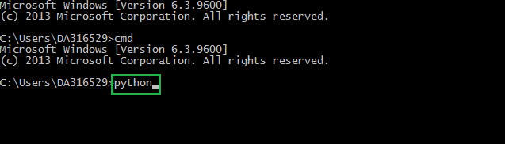

Step 2: Type the given program, line by line. When enter is pressed, the secondary prompt namely, “…” appears because of keyword if . When last line of if block is entered, press enter once again, in order to run the program. The following output is obtained. “Your application is accepted”
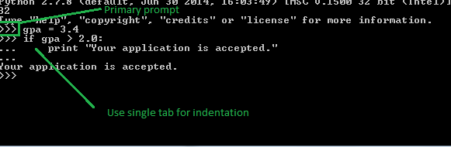

Use single Tab for indentation, without which it will throw an error.

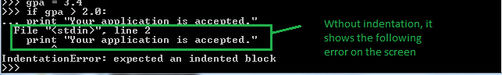

Step 3: To run the program, from command prompt itself, without starting python, do the following. Navigate to the directory having the python script and from the command prompt type python filename as shown below

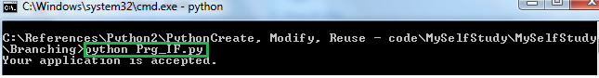

filename Prog_if.py

# Program to demonstrate basic if condition in branching
gpa = 3.4
if gpa > 2.0:
print “Your application is accepted.”

Branching if else Python

Objective: program to demonstrate if else condition in branching

Step 1: To run the program, from command prompt itself, without starting python, do the following. Navigate to the directory having the python script and from the command prompt type python filename as shown below

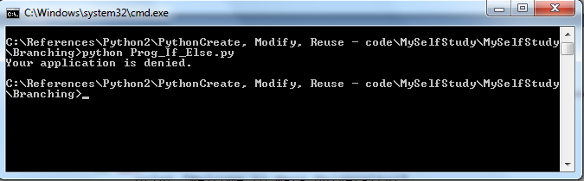

filename Prog_If_Else.py
# Program to demonstrate basic if else condition in branching
gpa = 1.4
if gpa > 2.0:
print "Welcome to Mars University!"
else:
print "Your application is denied."

Data structures Python
Objective: program to demonstrate data structures in python such as lists, dictionaries and tuples

List
Objective: program to demonstrate usage of a list

Step 1: To run the program, from python, type python at command prompt to obtain the primary prompt “>>>” and keep on typing the program, line by line.
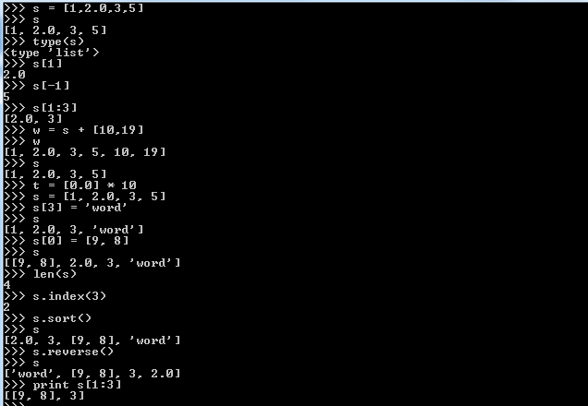

filename pList1.py
# Program to demonstrate usage of a list in python

s = [1,2.0,3,5]
s
type(s)
s[1]
s[-1]
s[1:3]
w = s + [10,19]
w
s
t = [0.0] * 10
s = [1, 2.0, 3, 5]
s[3] = 'word'
s
s[0] = [9, 8]
s
len(s)
s.index(3)
s.sort()
s
s.reverse()
s
print s[1:3]

Dictionary
Objective: program to demonstrate usage of a dictionary

Step 1: To run the program, from python, type python at command prompt to obtain the primary prompt “>>>” and keep on typing the program line by line.

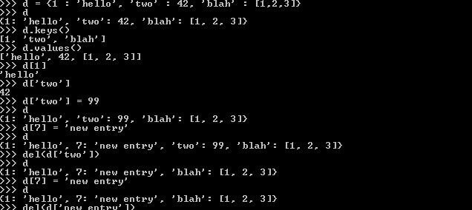

filename Dict1.py
# Program to demonstrate usage of a dictionary in python

d = {1 : 'hello', 'two' : 42, 'blah' : [1,2,3]}
d
d.keys()
d.values()
d[1]
d['two']
d['two'] = 99
d
d[7] = 'new entry'
d
del(d['two'])
d
d[7] = 'new entry'
d
del(d['new entry'])
d
d = {1 : 'hello', 'two' : 42, 'blah' : [1,2,3],two' : 42}
d

Tuple

Objective: program to demonstrate usage of a tuple

Step 1: To run the program, from python, type python at command prompt to obtain the primary prompt “>>>” and keep on typing the program, line by line.

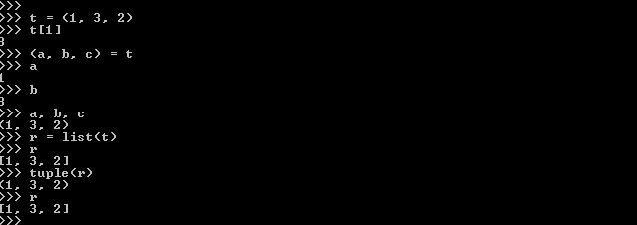

filename tuple2
# Program to demonstrate usage of a tuple in python

t = (1, 3, 2)
t[1]
(a, b, c) = t
a
b
a, b, c
r = list(t)
r
tuple(r)

Looping in Python

Objective: program to demonstrate looping using a for loop with range to iterate over lists, and dictionaries

Step 1: To run the program, from command prompt itself, without starting python, do the following. Navigate to the directory having the python script and from the command prompt type python filename as shown below
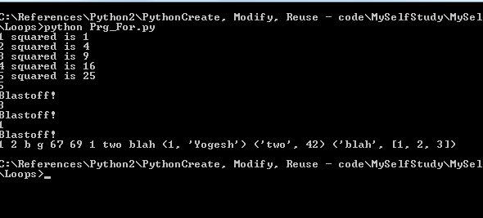

filename Prg_For.py
# Program to demonstrate looping using a for loop with
# range to iterate over lists, and dictionaries

# Printing a range
for x in range(1, 6):
print x, "squared is", x * x

# Printing a range with offset
for x in range(5, 0, -2):
print x
print "Blastoff!"

# Printing a List
a = [1,2,'b','g',67,69]
for i in a:
print i,

# Printing keys of a dictionary
d = {1 : 'Yogesh', 'two' : 42, 'blah' : [1,2,3]}
for i in d.keys():
print i,

# Printing items of a dictionary
for i in d.items():
print i,

Step 2: To run the program, from python, type python at command prompt to obtain the primary prompt “>>>” and keep on typing the program line by line, and using TAB for indentation, when the secondary prompt is obtained. Press “enter” once again, at the end of the block of each loop, to run the program.

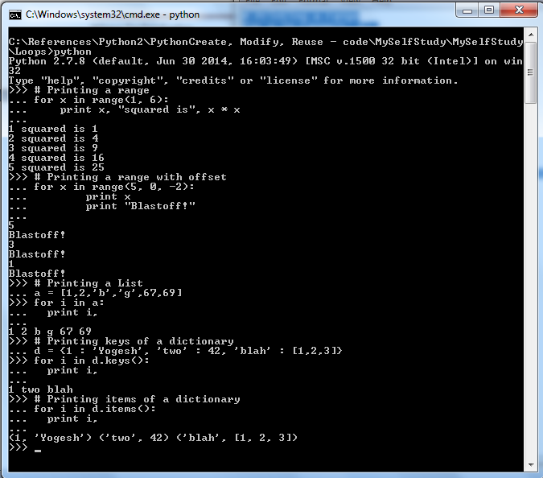
Objective: program to demonstrate looping using a while loop

Step 1: To run the program, from python, type python at command prompt to obtain the primary prompt “>>>” and keep on typing the program line by line, and using TAB for indentation, when the secondary prompt is obtained. Press “enter” once again, at the end of the block of each loop, to run the program.
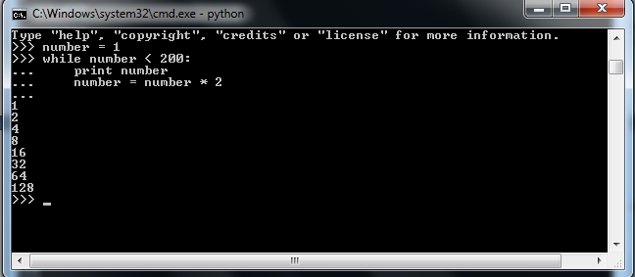
filename Prg_while.py
# Program to demonstrate looping using a while loop
number = 1
while number < 200:
print number
number = number * 2

Objective: program to demonstrate usage of keywords “break” and “continue” in loops

Step 1: To run the program, from python, type python at command prompt to obtain the primary prompt “>>>” and keep on typing the program line by line, and using TAB for indentation, when the secondary prompt is obtained. Press “enter” once again, at the end of the block of each loop, to run the program.

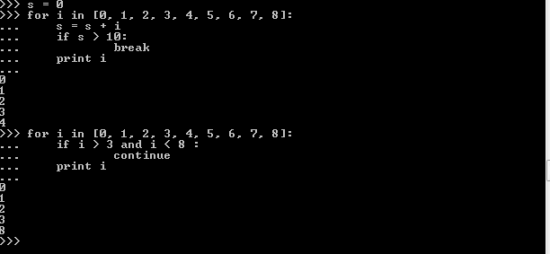

filename Pbreak1.py
# Program to demonstrate usage of “break’ and “continue” in loops

# The loop is exited when cumulative sum of numbers s > 10
s = 0
for i in [0, 1, 2, 3, 4, 5, 6, 7, 8]:
s = s + i
if s > 10:
break
print i

# The printing is skipped for a range 3 to 8 in the given list
for i in [0, 1, 2, 3, 4, 5, 6, 7, 8]:
if i > 3 and i < 8 :
continue
print i

Programs to demonstrate function calls in python

Objective: To demonstrate function calls in python and Pass by Object Reference

Step 1: To run the program, from python, type python at command prompt to obtain the primary prompt “>>>” and keep on typing the program line by line, and using TAB for indentation, when the secondary prompt is obtained. Press “enter” once again, at the end of the block of the function. Then make the function call to run the program.

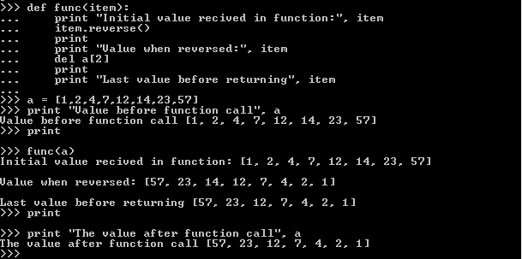

filename functions.py
# Program to demonstrate basic function call in python
def func(item):
print "Initial value received in function:", item
item.reverse()
print
print "Value when reversed:", item
del a[2]
print
print "Last value before returning", item

a = [1,2,4,7,12,14,23,57]
print "Value before function call", a
print
func(a)
print
print "The value after function call", a

Program to demonstrate generic function in python

Objective: To demonstrate generic function in python that can be used on numeric data, lists and stings as well

Step 1: To run the program, from python, type python at command prompt to obtain the primary prompt “>>>” and keep on typing the program line by line, and using TAB for indentation, when the secondary prompt is obtained. Press “enter” once again, at the end of the block of the function. Then make the function call to run the program.

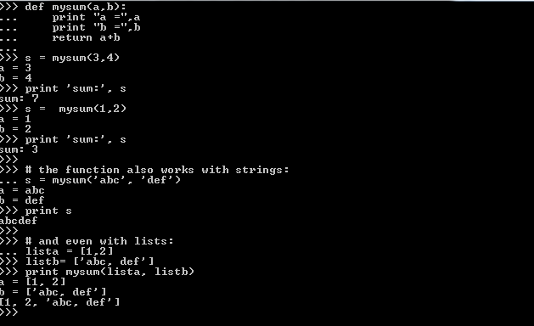

sample_functions.py
#Program to demonstrate a generic function to add 2 numbers, string and lists

def mysum(a,b):
print "a =",a
print "b =",b
return a+b

s = mysum(3,4)
print 'sum:', s
s = mysum(1,2)
print 'sum:', s

# the function also works with strings:
s = mysum('abc', 'def')
print s

# and even with lists:
lista = [1,2]
listb= ['abc, def']
print mysum(lista, listb)

Programs to demonstrate basic use of classes in python

Objective: To demonstrate creation objects from a calls and invoking the methods

Step 1: To run the program, from command prompt itself, without starting python, do the following. Navigate to the directory having the python script and from the command prompt type python filename as shown below

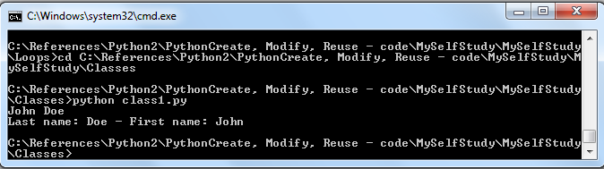

filename class1.py

# Program to demonstrate creation of objects from a class

#class definition
class Person:

#Constructor
def __init__(self, lastname, firstname):
self.lname = lastname #member variables
self.fname = firstname #member variable

def get_fullname(self): #method
return '%s %s' % (self.fname, self.lname)

def display(self):
print self.get_fullname()

def __str__(self):
return "Last name: %s - First name: %s" % \
(self.lname, self.fname)

#Instantiation of object
p = Person('Doe', 'John')
#Invoking method
p.display()
print p

Objective: To demonstrate creation objects from a calls and invoking the methods

Step 1: To run the program, from command prompt itself, without starting python, do the following. Navigate to the directory having the python script and from the command prompt type python filename as shown below

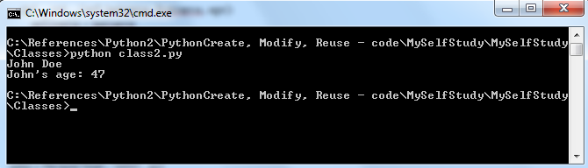

filename class2.py

# Program to demonstrate creation of objects from a class

#class definition
class Person:

def __init__(self, lastname, firstname, age):
self.lname = lastname
self.fname = firstname
self.age = age

def get_fullname(self):
return '%s %s' % (self.fname, self.lname)

def add_years(self, years):
self.age += years

john = Person('Doe', 'John', 45)
print john.get_fullname()
john.add_years(2)
print "John's age:", john.age

Objective: To demonstrate creation objects from a calls and invoking the methods

Step 1: To run the program, from command prompt itself, without starting python, do the following. Navigate to the directory having the python script and from the command prompt type python filename as shown below

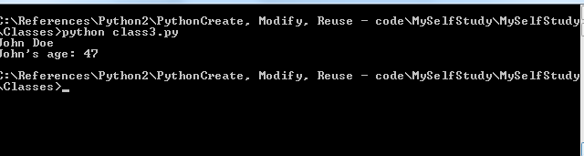

filename class3.py

# Program to demonstrate creation of objects from a class and invoking the methods

#class definition
class Person:

def __init__(self, lastname, firstname, age, children=None):
self.lname = lastname
self.fname = firstname
self.age = age
self.children = children
if children == None:
self.children = []

def get_fullname(self):
return '%s %s' % (self.fname, self.lname)

def add_years(self, years):
self.age += years

john = Person('Doe', 'John', 45)
print john.get_fullname()
john.add_years(2)
print "John's age:", john.age

Programs to demonstrate file operations in python

Objective: To demonstrate how to open file in read mode and display contents on the console and count the no. of lines

Step 1: To run the program, from python, type python at command prompt to obtain the primary prompt “>>>” and keep on typing the program line by line, and using TAB for indentation, when the secondary prompt is obtained. Press “enter” once again, at the end of the block of each loop, to run the program.
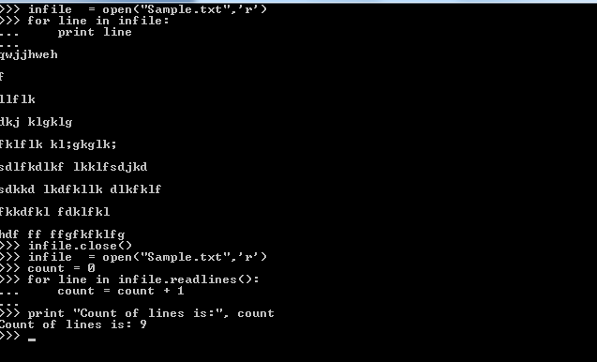

filename PrgFile1.py
# Program to open file in read mode and display contents on
# the console and count the no. of lines

#Open file in read mode
infile = open("Sample.txt",'r')

#Iterate through conents and print it line by line
for line in infile:
print line

#Close the file
infile.close()

#To count the number of lines in a .txt file
infile = open("Sample.txt",'r')
count = 0
for line in infile.readlines():
count = count + 1
print "Count of lines is:", count

Objective: To demonstrate how to read contents of file and create a copy of the contents, in upper case and write the same, to another .txt file

Step 1: To run the program, from python, type python at command prompt to obtain the primary prompt “>>>” and keep on typing the program line by line, and using TAB for indentation, when the secondary prompt is obtained. Press “enter” once again, at the end of the block of each loop, to run the program.

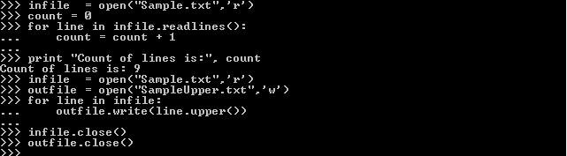

filename PrgFile2.py

# Program to open file in read mode create copy of # contents
# in upper case, by writing it to another file

# Open file in read mode
infile = open("Sample.txt",'r')

#Create file for writing
outfile = open("SampleUpper.txt",'w')

#Iterate through 1st file and write contents to new file created
for line in infile:
outfile.write(line.upper())

#Close the files
infile.close()
outfile.close()

Program to demonstrate how to accept inputs to program from user

Objective: To demonstrate how to receive input data from user, while running a python program, at command prompt

Step 1: To run the program, from python, type python at command prompt to obtain the primary prompt “>>>” and keep on typing the program line by line. Having done that, type in a word, when program prompts user for input, with message as can be seen below. The program then prints the supplied word on to the screen.

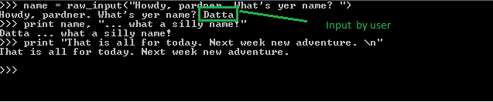

frilename raw_inp.py

#Program to demonstrate of to accept input data from user at command prompt

name = raw_input("Howdy, pardner. What's yer name? ")
print name, "... what a silly name!"
print "That is all for today. Next week new adventure. \n"

